Docker is an Tool which provide container to ship the whole application with its environment setup to the server.

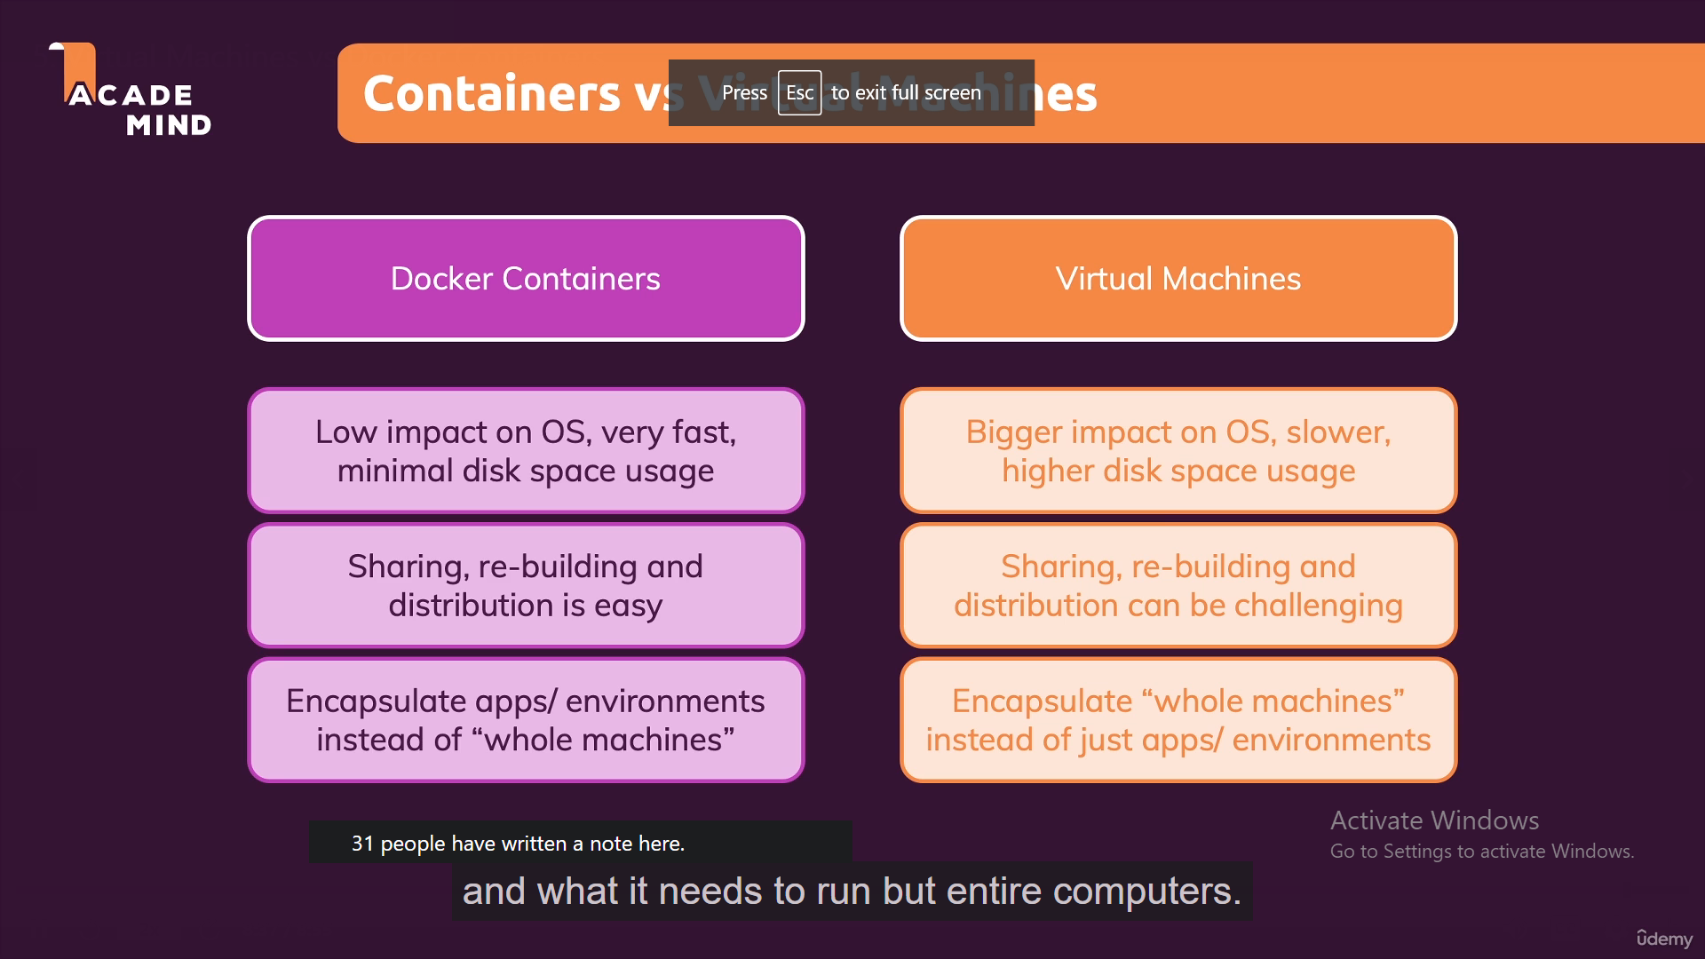

Make Docker File and write commands and ” run docker build .”

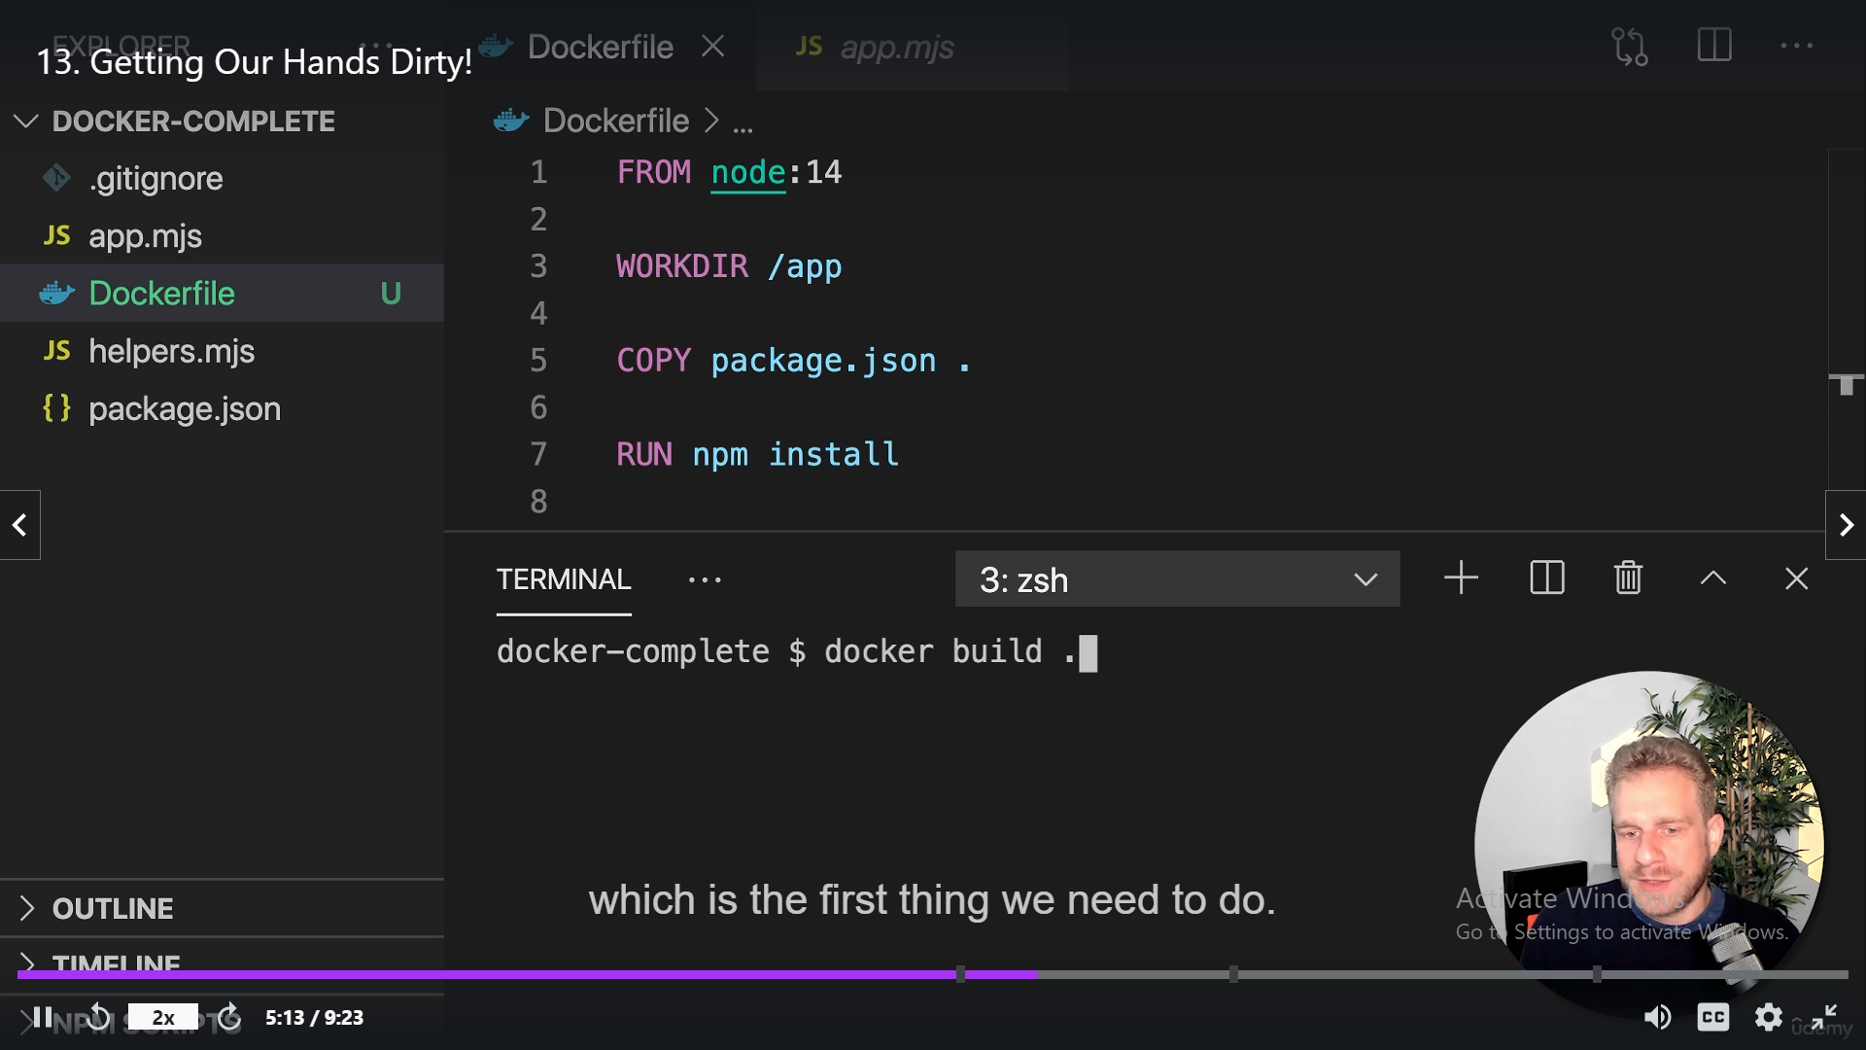

docker run -p 3000:3000 d2cc7b04fb0a

d2cc7b04fb0a is image ID

-p 3000:3000 it will make the port open in docker where our localhost will communicate.

Images are Blueprint of container which help to run multiple containers.

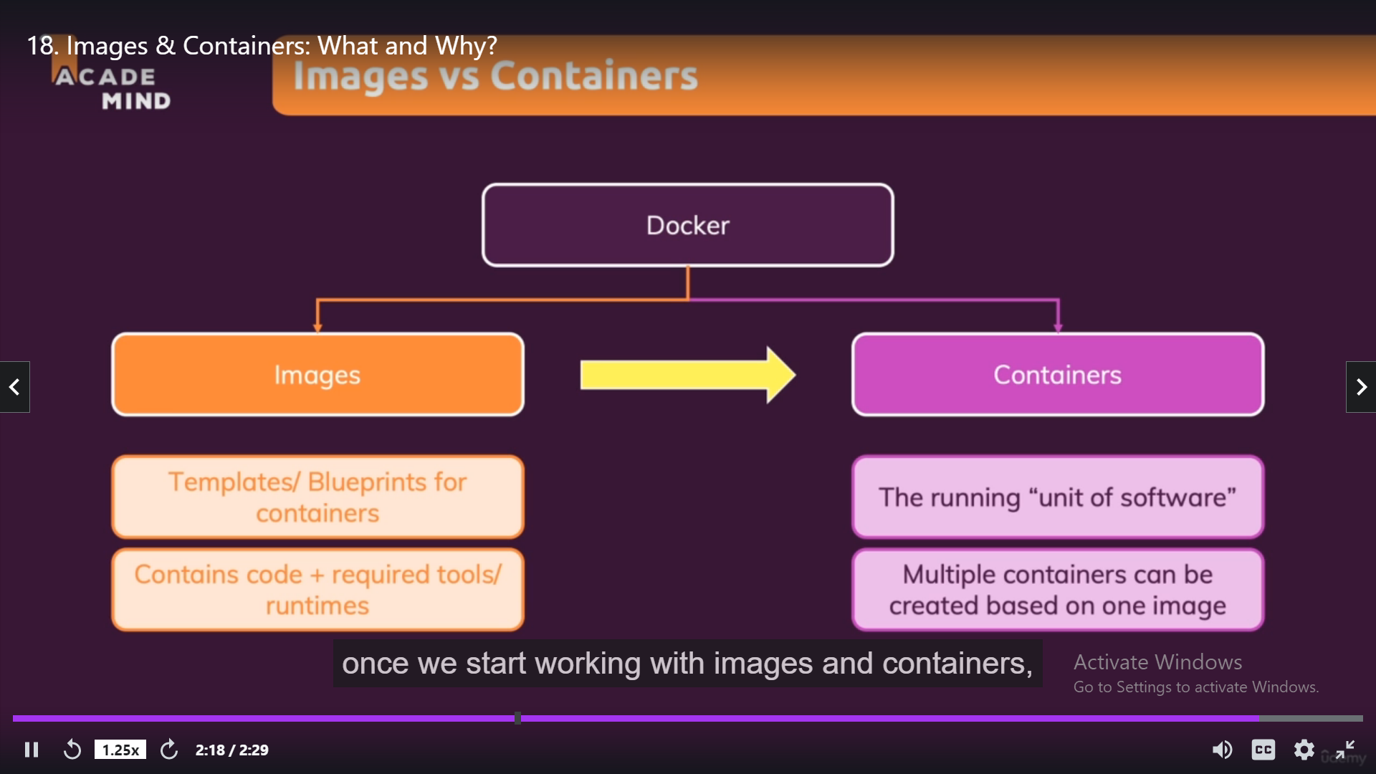

Docker build . -> command use to build new Image

Docker ps -a -> this will list all active containers.

Docker start imageId -> will restart the container.

Docker start -a -I ImageId (interactive mode and attach Mode).

Docker Don’t only used for Servers also used for any language Interaction like python e.g enterning Input. Like Using Input().